Phase I - Re-opening of Wadebridge Town Centre

Wadebridge Hope Volunteers; in partnership with Cornwall Council, CORMAC, The Mayor of Wadebridge Town Council & the Chamber of Commerce have been working on plans to re-open the Town following the Government’s announcement that from Monday 15 June non-essential retail will be allowed to re-open.

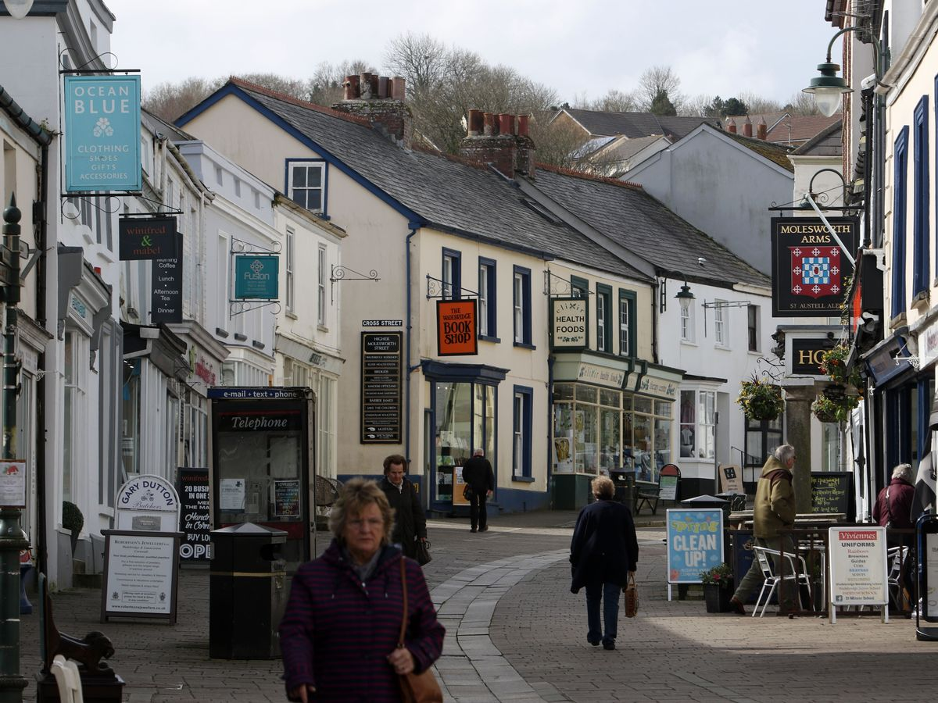
On Monday 15 June non-essential retailers will be allowed to reopen ………………….

Preparations are well underway to help ensure Wadebridge is safe and welcoming when many stores reopen their doors next week.
On Monday 15 June non-essential retailers will be allowed to reopen for the first time since the end of March. Together we have developed this short public awareness plan; Phase I, please note we are in the process of obtaining ERDF Grant funding to help purchase necessary equipment. There are ways you can help … full details are set out in the plan; we always welcome feedback to help take this next step together…….

Temporary and permanent measures and changes are required to ensure the town centre remains a vibrant place to live, work, socialise, visit, shop and work.

Social distancing measures must be in place to ensure the safety of shoppers.

Our Plan:
Public Realm
A real emphasis will be on keeping public space clean through street cleaning and ensuring rubbish bins are emptied – we are asking everyone to help keep our town clean and tidy by ensuring you place your rubbish in bins provided.
Temporary signage will support social distancing through Molesworth Street and adjoining areas/streets. (We are in the process of ordering signs – hope to be able to update delivery date).
Our aim is to supply hand sanitisers to every shop.

It is key that the business community engage with their own deep cleaning.
Stores will limit the number of customers inside to allow two metre social distancing to be followed. Markings may be placed outside stores to assist with the spacing of queues.
It is not yet clear how many stores will reopen on June 15, some stores have indicated a phased return to reopening. It is also thought shops may re-open on reduced hours in the first instance 10-3pm.

The town centre preparations are being coordinated by the Wadebridge Hope Volunteers in partnership with Cornwall Councillors, The Mayor of Wadebridge also representing the Chamber of Commerce and its partners, including Concern Wadebridge and CORMAC our aims are to achieve:
- A safe re-opening of the town centre
- A steady return to sustainable footfall levels

In order to achieve we have put together a simple FIVE key stage plan.

 | Wadebridge Re-opening Plan – Key Steps
ONE | Communication  We will be providing information and updates from a dedicated page on the Wadebridge Town Council website – this will be linked to Cornwall Council’s website and various social media sites.
TWO | Information – we will be linking to Cornwall Council’s extensive Covid information site Cornwall/information-about-coronavirus-covid-19/  and key Government advice on safety in shops working-safely-during-covid-19-shops-branches  It is important to note that things are moving fast and information sites are regularly updated.
THREE | Public Signage  The Town Volunteers will facilitate the roll out of public signage and messages on behaviour and advice for shoppers to maintain social distancing. Our aim is to provide the following signage: Pavement Signs, Shop Window Signs, Social Distancing Floor Stickers and Queueing Spots. (Please note we have applied for ERDF grant funding and identified manufactures and will be installed at the earlies possible convenience).
FOUR | Clean - It is vital that all areas of the town appear welcoming, clean and sanitised….  Hand sanitisers will be made available to every shop together with associated signage. Our aim is also to provide PPE.  A real emphasis will be on street cleaning the public place and rubbish removal.  Wadebridge our Town  The Town Team can manage the public areas but it is key that the business community engage with deep cleaning, painting shop fronts (as appropriate) etc.  Public Conveniences – the Wadebridge Town Council will be re-opening public toilets from 15 June, social distancing signage will be posted as appropriate.
FIVE | Safe Social Distancing  The Town volunteers will be facilitating the roll out of public signage and messages on behaviour from Monday we will have 4 volunteers assisting this process in the town, if anyone would like to help please contact Andy at Concern Wadebridge a.lyle@concernwadebridge.org.uk  The Town volunteers will be looking at options with Cornwall Council and COMAC in relation to highways car parks and pedestrian friendly environment to ensure safe distancing.  Molesworth Street  As you are aware the street is open to traffic, mainly being used by delivery vehicles for business. In order to avoid potential vehicle / pedestrian / cyclist conflict during this sensitive time we are working with CORMAC to provide planters to assist creating safer pedestrian access & areas for shoppers who may be queueing to maintain social distancing these are on order and hope to be provided in Phase II – please be aware only vehicles that should be permitted to use Molesworth Street are emergency services, taxi's, Disabled and deliveries.

We have tried to do our best with the resources and time available, we ask that you take this into consideration should everything not be as you would have liked. The town centre is a corner stone of our community – working together we can take this first step, we envisage further guidance will be issued in due course on the re-opening of hospitality businesses, we will aim to support by a further plan in due course.

We appreciate all feedback, via social media or if you see our volunteers out and about they will be happy to have a chat……. Please remember they are volunteers giving their time to our town.

